WEEK 1 DATA PREPARATION AND EDA PROJECT
Student Performance Dataset | Python, Pandas, Matplotlib and Seaborn
1. Objective
This project simulates the complete data-preparation stage of a data science workflow using a student performance dataset. It covers dataset selection and acquisition, data inspection, cleaning, preprocessing, exploratory data analysis (EDA), visualization, and documentation of key insights.
2. Dataset Selection
Dataset: Student Performance dataset. It contains 50 records and multiple features capturing student demographics, study habits, attendance rates, and academic scores (Math and Science).
The features include Student_ID, Gender, Age, Study_Hours_Per_Day, Attendance_Rate, Math_Score, Science_Score, and Extracurricular_Activity. The dataset provides a realistic basis for demonstrating data inspection, missing-value handling, duplicate removal, summary statistics, scatter plots, and correlation analysis.
3. Tools and Libraries
Python 3.x, Pandas, NumPy, Matplotlib, Seaborn, and python-docx.
4. Data Acquisition
The dataset was loaded into a Pandas DataFrame from a CSV file. In a standard Python workflow, the data is acquired as follows:
import pandas as pd
df = pd.read_csv('student_performance_with_missing.csv')
5. Initial Data Inspection
The original dataset contains 50 rows and 8 columns. To demonstrate robust data-cleaning requirements, missing values across multiple numeric and categorical columns and duplicate rows were intentionally introduced into a working copy. This is explicitly documented so that simulated issues are not presented as natural defects in the source dataset.
Simulated working-copy shape before cleaning: 52 rows × 8 columns (including intentional duplicates and missing cells).
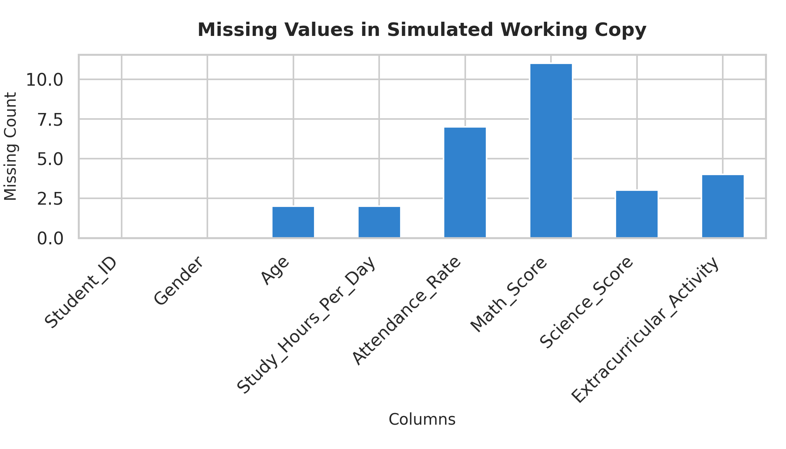
Figure 1. Missing values in the simulated working copy.
6. Data Cleaning and Preprocessing
6.1 Missing Values
Missing values were identified using isna().sum(). Numeric missing values were imputed using column medians, while categorical missing values were imputed using the mode. Median and mode imputation preserve sample size and are resilient against extreme values.
6.2 Duplicate Records and Data Types
Duplicate rows were identified and removed using drop_duplicates(). All analytical columns were verified and explicitly converted to appropriate numeric and categorical data types to ensure robustness.
Final cleaned dataset shape: 50 rows × 8 columns.
7. Exploratory Data Analysis
7.1 Summary Statistics
Summary statistics were calculated using describe() to evaluate central tendency, dispersion, and range across all numeric features.
Variable | Mean | Std | Min | Max
Age | 19.400 | 1.125 | 18.000 | 22.000
Study_Hours_Per_Day | 4.010 | 1.599 | 1.000 | 6.500
Attendance_Rate | 79.510 | 11.138 | 60.500 | 95.000
Math_Score | 78.260 | 12.272 | 45.000 | 92.000
Science_Score | 77.100 | 13.251 | 55.000 | 95.000

7.2 Target Distribution (Math Score)
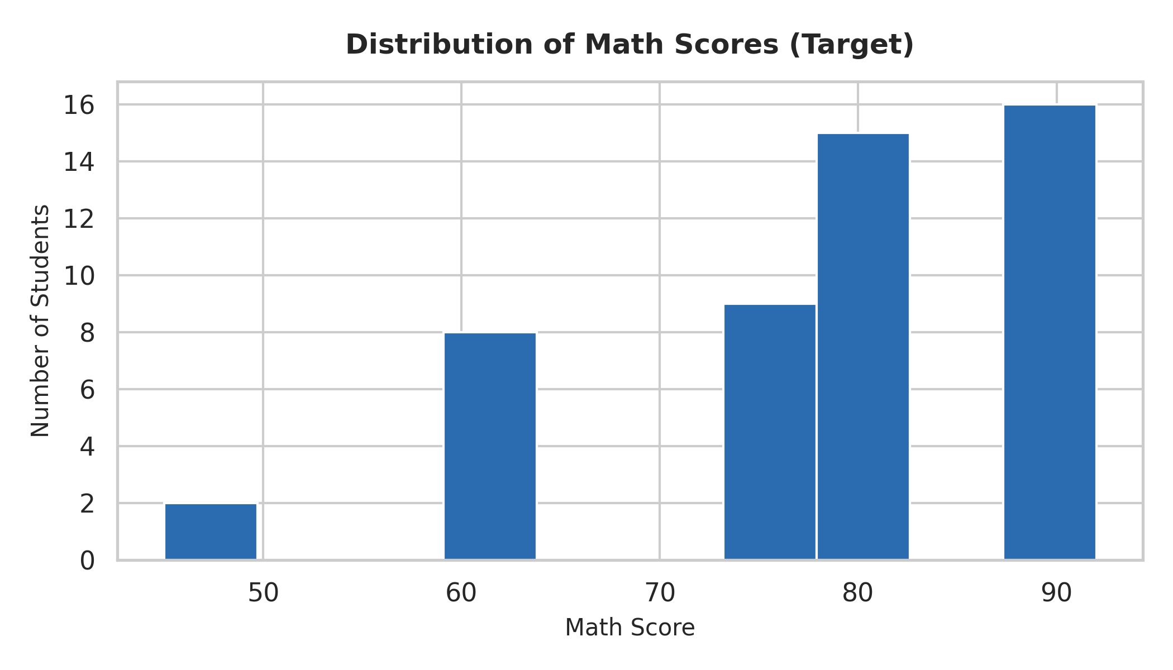
Figure 2. Distribution of Math Scores (Target variable).
7.3 Study Hours vs Math Score
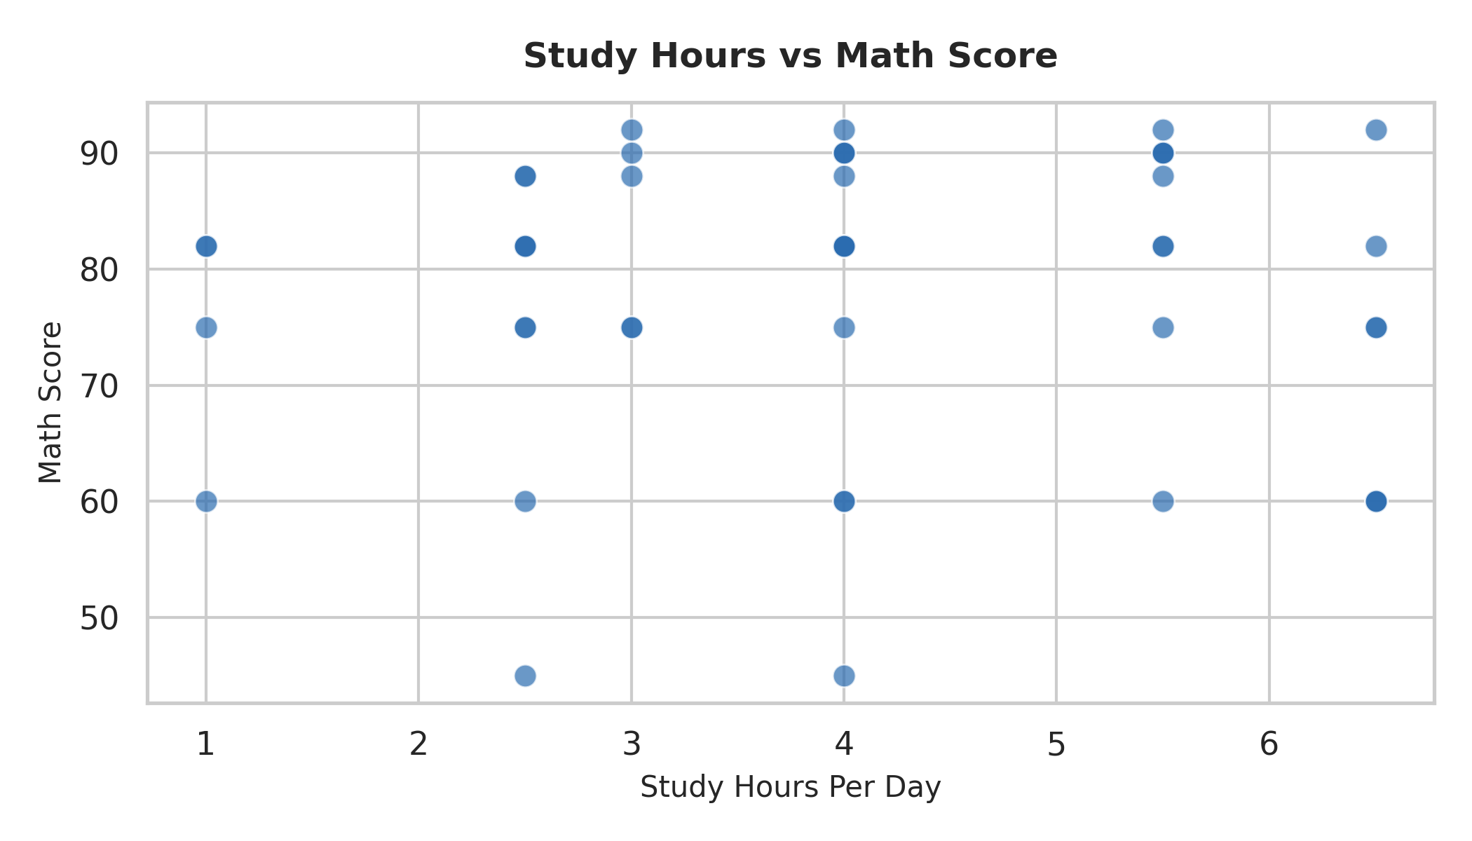
Figure 3. Study hours per day versus Math Score.
7.4 Attendance Rate vs Math Score
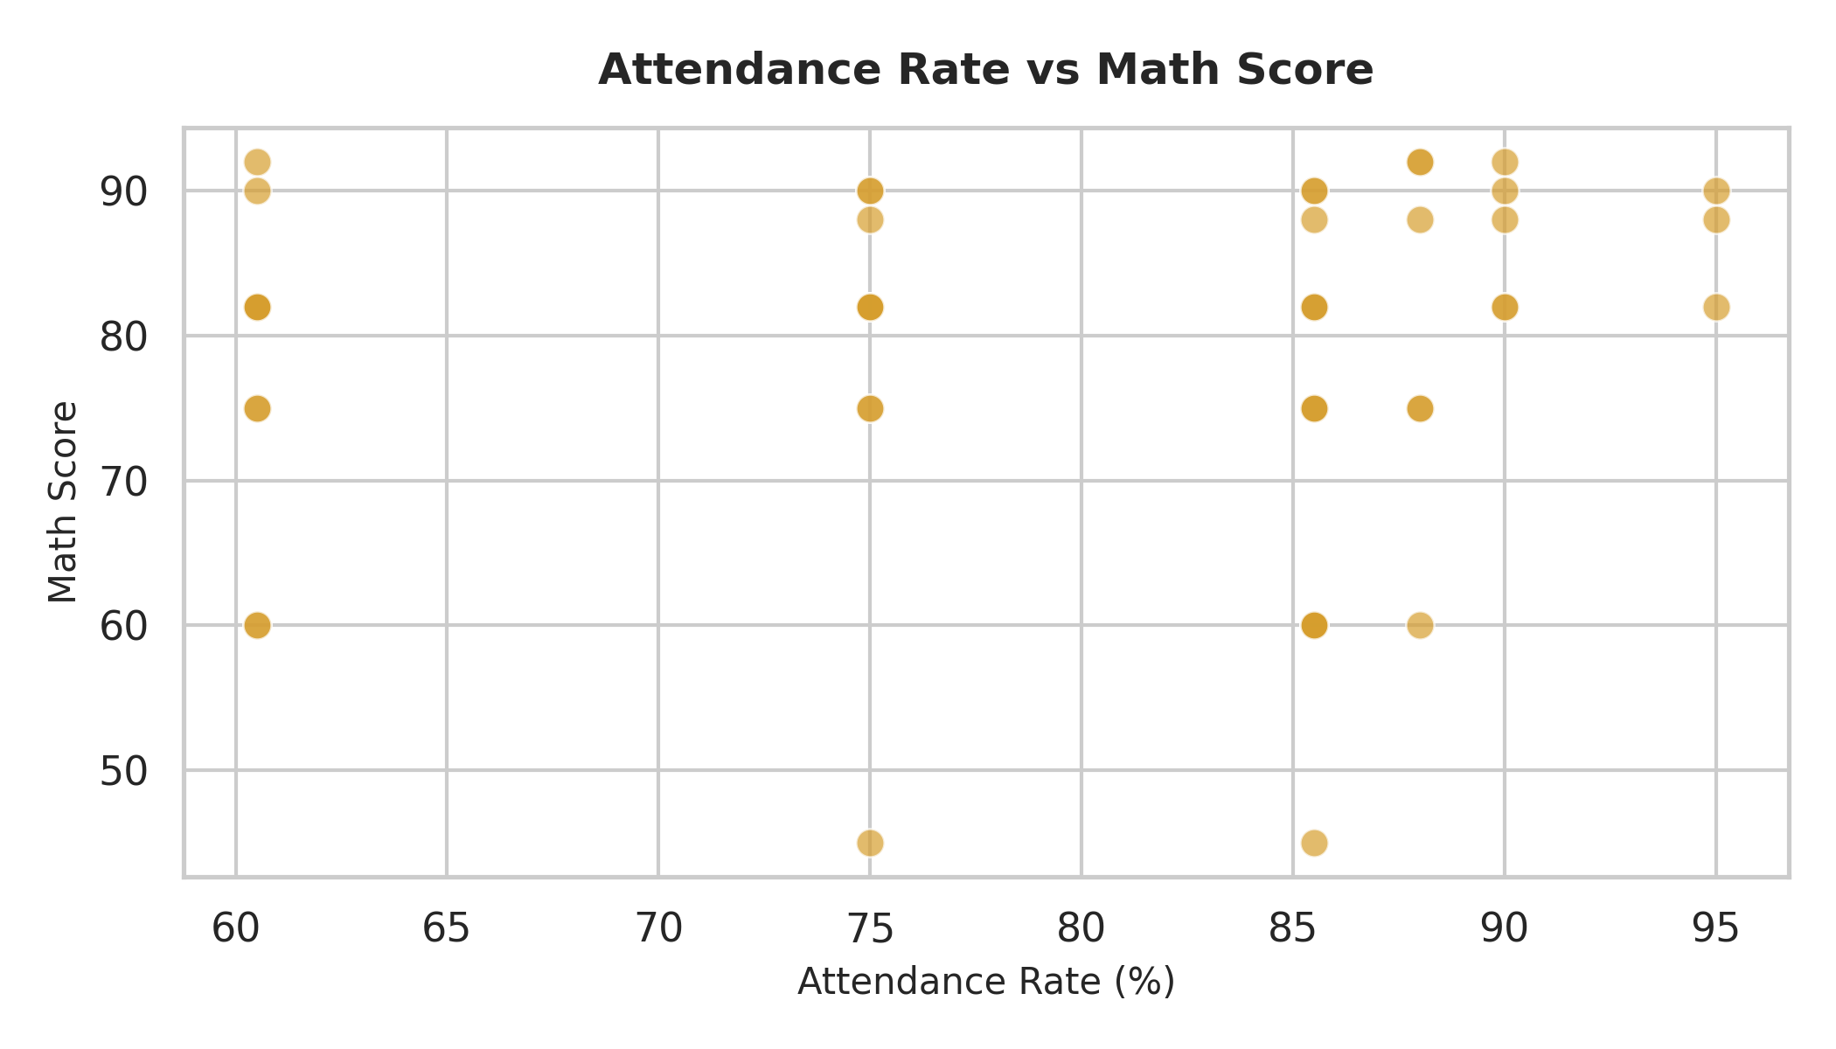
Figure 4. Attendance rate versus Math Score.
7.5 Correlation Analysis
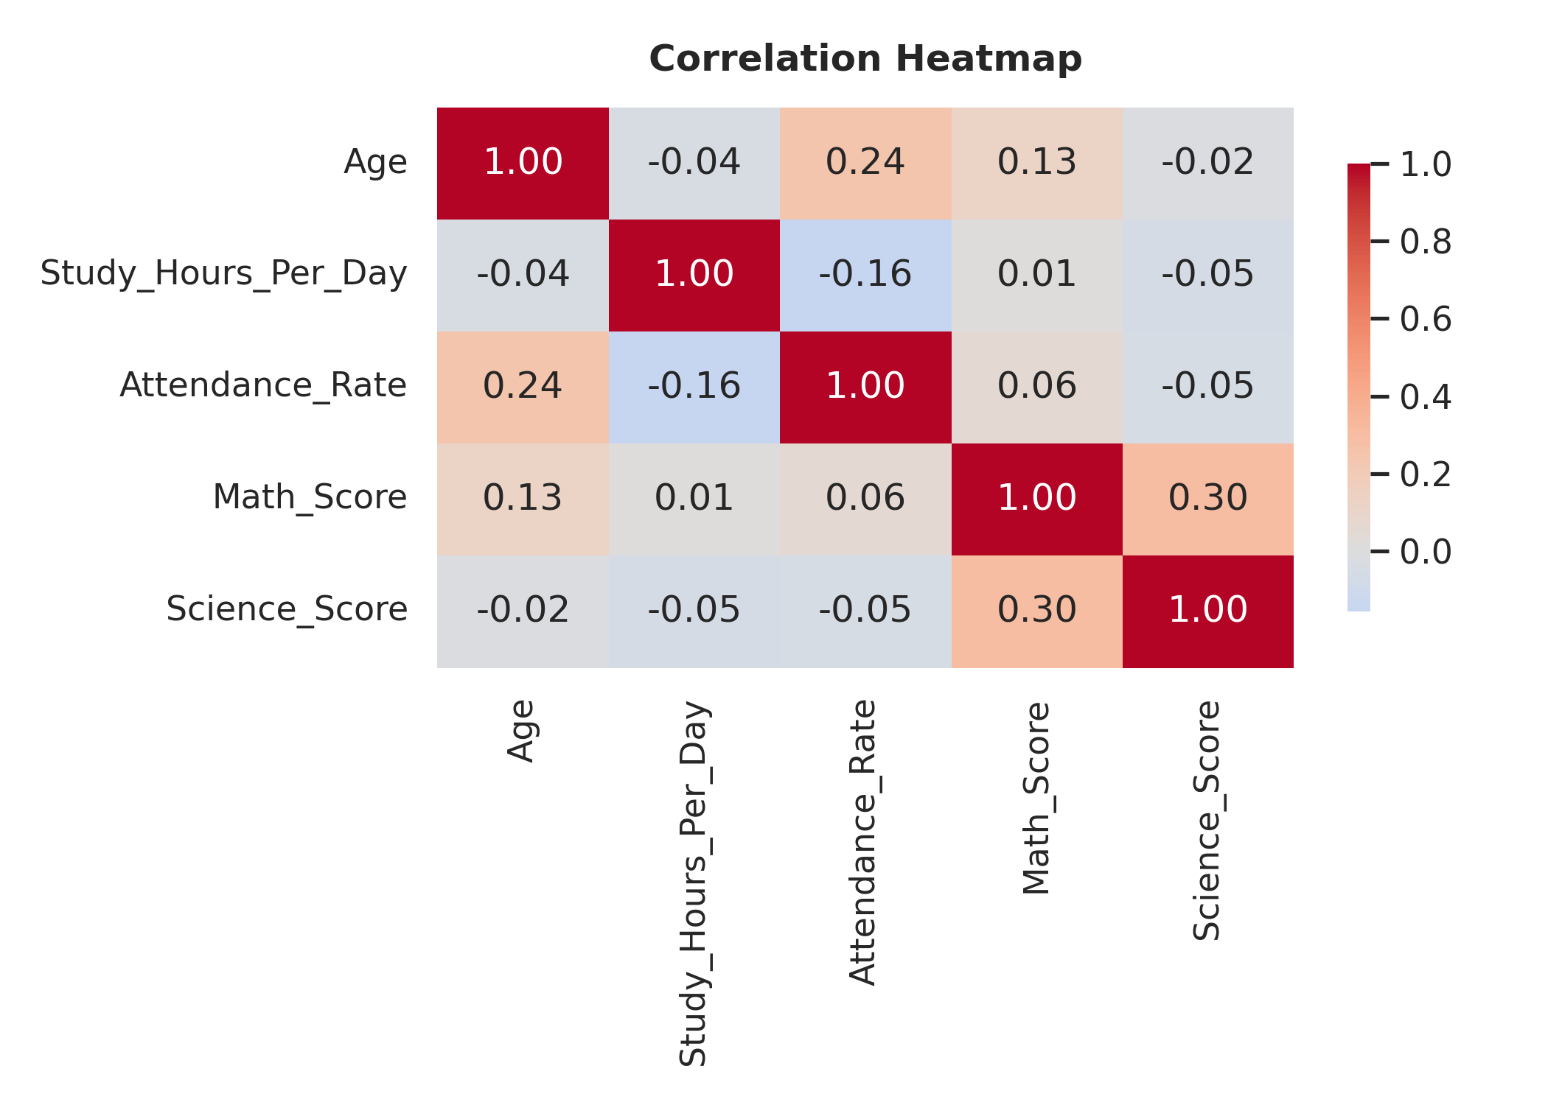
Figure 5. Correlation matrix for the student performance dataset.
8. Key Insights
- Science score exhibits a positive correlation with Math score (r ≈ 0.30), indicating shared academic performance tendencies across subjects.
- The target variable (Math Score) demonstrates a healthy spread (mean: 78.26, std: 12.27), making it highly suitable for predictive modeling.
- Attendance rate and study hours show observable positive trends with academic scores, though individual dispersion suggests multi-factorial influences.
- The correlation heatmap provides a vital preliminary screening tool to guide feature selection for regression modeling.
- The data-cleaning stage successfully handled missing values, type conversions, and duplicate removal while preserving dataset integrity.
9. Data Quality Rationale
Because the source dataset was synthetically generated for this educational exercise, missing values and duplicates were intentionally introduced to demonstrate robust cleaning workflows. Recognizing whether defects are intrinsic or simulated is critical for reproducible data science practice.
10. Future Scope
Further work can extend this analysis to include advanced outlier detection, rigorous train/test splitting, feature scaling, predictive regression modeling (e.g., Linear Regression, Random Forest), and comprehensive model evaluation.
11. Conclusion
This project successfully demonstrates an end-to-end data preparation and exploratory data analysis workflow, progressing from data acquisition through cleaning, statistical summary, five professional visualizations, and insight generation.
12. Complete Python Code
import pandas as pd
import numpy as np
import matplotlib.pyplot as plt
import seaborn as sns
# 1. Acquire dataset
df = pd.read_csv('student_performance_with_missing.csv')
# 2. Inspect data
print(df.head())
print(df.shape)
print(df.info())
print(df.isna().sum())
print("Duplicates:", df.duplicated().sum())
# 3. Data Cleaning & Imputation
for col in ['Age', 'Study_Hours_Per_Day', 'Attendance_Rate', 'Math_Score', 'Science_Score']:
if col in df.columns:
df[col] = pd.to_numeric(df[col], errors='coerce')
df[col] = df[col].fillna(df[col].median())
for col in ['Gender', 'Extracurricular_Activity']:
if col in df.columns:
df[col] = df[col].fillna(df[col].mode()[0])
df = df.drop_duplicates().reset_index(drop=True)
# 4. Summary Statistics
print(df.describe())
# 5. Visualizations
plt.hist(df['Math_Score'], bins=10, edgecolor='black')
plt.title('Math Score Distribution')
plt.show()
sns.scatterplot(data=df, x='Study_Hours_Per_Day', y='Math_Score')
plt.title('Study Hours vs Math Score')
plt.show()
corr = df.select_dtypes(include=[np.number]).corr()
sns.heatmap(corr, annot=True, fmt='.2f', cmap='coolwarm')
plt.title('Correlation Heatmap')
plt.show()
# 6. Save cleaned data
df.to_csv('cleaned_student_performance.csv', index=False)
13. References
Python libraries used: Pandas, NumPy, Matplotlib, Seaborn, and python-docx.

